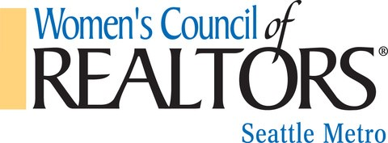



2024

Strategic Partnership Invitation

Information and Application



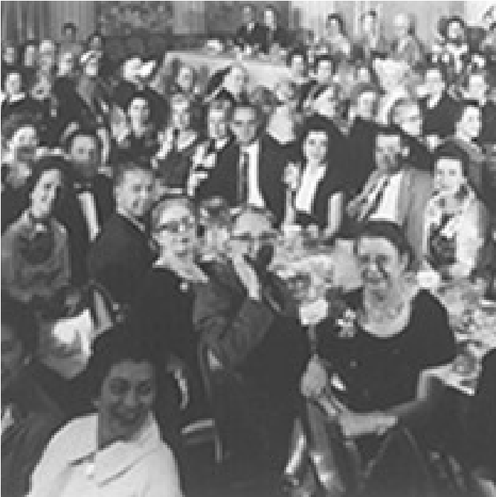

History of

In 1924, the California Real Estate Association formed a

Women's Division, after members founded the idea on a train

ride home from the National Association's convention in

Washington, D.C. Fourteen years later, Joseph Catherine, the

1938

president of the NATIONAL ASSOCIATION OF

REALTORS® (then called the National Association of Real

Estate Boards), encouraged the formation of the Women's

Council after being impressed by the California group and the

immense potential of women in real estate.

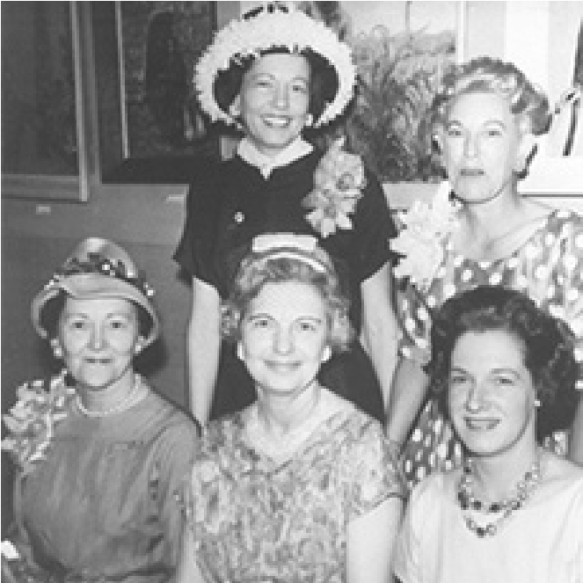At the time, NAR was already 30 years old and most decisions were still made at the Local Board level. Unfortunately, most Local Boards were still resistant to women; however, the National Association was ready to recognize women in real estate and a positive vote resulted in the formation of a women's division at the Annual Convention held in Milwaukee in November of 1938. Thirtyseven ambitious women represented nine states at that meeting and WCR's inception. Through the decades, WCR's membership growth reflected the vast number of women choosing a career in real estate.

Women began to recognize the immense benefits of careers in real estate. Combined with a

WCR membership, including:

Salaries equitable to men's since "commission is commission."

Flexible work schedules allowing REALTORS® the ability to raise a family and have a career instead of choosing one or the other.

A support system of women in the same field garnering many friendships, networking capabilities - and referrals.

Gaining confidence through association with other professional women REALTORS®. Recognition for their own achievements and success, as well as inspiration and courage to strive for greater successes.

Today Women's Council is a nationwide community of 13,000 real estate professionals who include many of the best and brightest in the business. The backbone of the Council is its

network of more than 250 local and state networks in nearly 40 states with volunteer managers trained to position their groups as a business resource in their REALTOR® communities.

This structure represents the largest Networks infrastructure in the REALTOR® family, that represents 1,200 elected officers that drive over 1,500 programs annually that focus on business leadership.





Hello, My name is Lori Hughes, the 2024 Seattle Metro President. I am so excited and honored to be a part of such a strong Leadership Network.

As members of the Women's Council of REALTORS®, we are part of a powerful force of women who are making a difference in the industry and our communities. We are proud to have leaders made here and to continue shaping the industry’s future.

Our new slogan for 2024, ‘**Follow your COMPASS,**' represents the limitless potential we have when we come together and support one another. By lifting each other up, we can reach new heights and accomplish great things

So let's embrace this new year with open hearts and a fierce determination to succeed. Let's continue to be a driving force for change, not just in the industry but the world. And let's always remember that by working together, there is no limit to what we can achieve and no limit to the leaders we can create.

I joined Seattle Metro Network in 2021. I wanted to learn more about being the best REALTOR I could be and learn from some of the best. I have realized how much I did not know. I gained friends and colleagues who have helped me professionally and personally, and I’m learning every day to step out of my comfort zone.

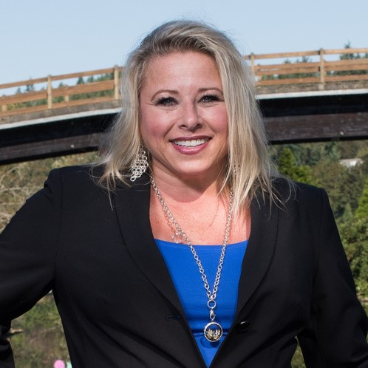

For my year as president, the organization I want to help is The Sophia Way, Sophia, a name derived from σοφία, the Greek word for “wisdom.” Her vision was that the “Way” is the path we seek to walk alongside the women in need to support them from homelessness to housing.

We Come Together, Learn Together, Work Together, Grow Together, Play Together, and Give Together.

Make every connection matter in 2024.

Lots of Smiles,

Lori Hughes

Women's Council of REALTORS® Seattle Metro

2024 President

Email: lori@corcoranlp.com

Phone: (425)681-4660

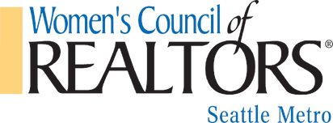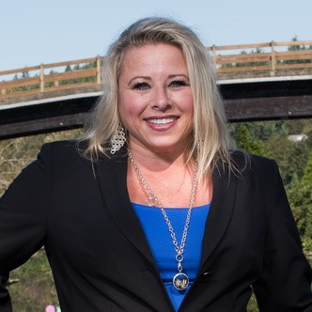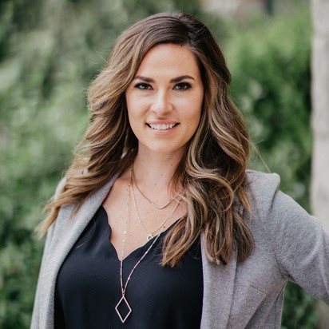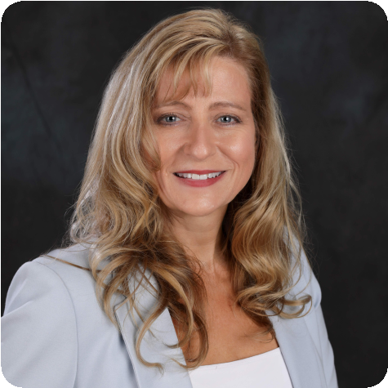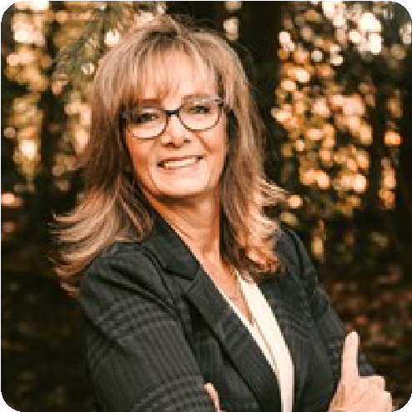

**We are a network of**

**successful REALTORS®**

**advancing women as**

**business leaders in the**

**industry and**

**communities**

**we serve.**

**Our Mission**

**Statement**

**Lori Hughes**

President

**Shawna Rexroat**

Treasurer

**Laura Hinds**

President- Elect

**Meet our 2024**

**Governing Board**

**Camey Westermark**

Membership Director

**Ferrah Seifert**

Events Director

1

. Women's Council is a dynamic, accessible, and diverse Network, linking

each member to the tools, training, and support to develop their individual

leadership potential and business goals.

2

. Women's Council identifies, supports, and promotes the development of strong

women business leaders in the industry, organized real estate, and the broader

community.

3

. Women's Council provides an influential voice and perspective for women in real

estate.

4

. Women's Council's local and state Networks consistently deliver high membership

value and a collaborative, welcoming environment in which Members can achieve

their business goals.

5

. Women's Council is an efficient organization with the structure and capacity

to fulfill the Council's mission and vision with excellence.

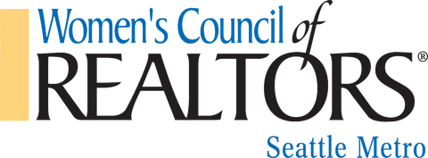

The Women's Council of REALTORS ® is recognized as the voice for women in

real estate, and the premier source for the development of leaders in the

industry, organized real estate and beyond.

**Our Vision Statement**

**Our Long Term Goals**



**Become a Women's Council Strategic Partner Who are Women's Council Members?**

Highly successful Professional REALTORS ®

Earn more than two times the average REALTOR ®

In business 25% longer than average REALTOR ®

Generate an average of 50% of real estate business from referrals Have a 'referral mindset'

Our Members include professional women and men leading the way in our real estate community. We continue to create leaders for our industry and the communities we serve. We are better together, and we look to include a diverse group of Partners to reflect our Members mission and vision. We hope to have you as part of our team in 2024!



**Why Strategic Partner and not Member?**

REALTORS ® are 'Members.'

The local Women's Council network is focused on building a strong base of REALTOR ® members to benefit REALTORS ® and to provide access to Strategic Partners to a broader base of successful professionals in the industry.

**Strategic Partner** distinguishes and positions affiliated companies as trusted advisors providing expertise and services in pursuit of a mutual goal - to help clients buy and sell homes.

**What are the Benefits of Being a Strategic Partner?**

There are a variety of levels and benefits available to suit Strategic Partners marketing budget and goals

Benefits provide many ways to be visible and opportunities to build productive relationships with REALTOR ® members

We offer Strategic Partnership opportunities to showcase their products and services in addition to their experience and expertise

Benefits offer Strategic Partners the opportunity to become an indispensable part of the REALTOR ® professional network of experts to better serve their clients

**Ask us how you can Level Up your 2024 Strategic Partnership!**

|  |  |  |  |  |  |
| --- | --- | --- | --- | --- | --- |
| **Strategic Partnership Benefits** | **Diamond $10,000** | **Platinum $5,000** | **Gold $2,500** | **Silver $1,500** | **Bronze $750** |
| **Exclusive to one Strategic Partner Per**  **Industry\*** |  |  |  |  |  |
| **Business logo displayed on table tents &**  **Slide Show at Meetings (slideshow when**  **available)** |  |  |  |  |  |
| **Strategic Partner Spotlight on Social Media**  **(Headshot, Bio, & Logo to be provided by**  **Strategic Partner)** | **4** | **2** | **1** | **1** | **1** |
| **Logo Recognition on Women’s Council of**  **Realtor’s Seattle Metro Micro Site** |  |  |  |  |  |
| **Complimentary Lunch & Learns** | **10** | **8** | **4** | **2** | **1** |
| **Complimentary Lunch & Learns (for REALTOR ® Guests)** | **10** | **6** | **3** | **2** | **1** |
| **Link directing to Strategic Partner website on Women’s Council of REALTORS ® Seattle Metro Micro Site** |  |  |  |  |  |
| **2 Minute presentation/Commercial at meeting/Lunch & Learn** | **4** | **3** | **2** | **1** | **1** |
| **Opportunity to sponsor additional Events, Fundraisers, & Give-aways.** | **1**  **st**  **Choice** | **2nd**  **Choice** | **3rd**  **Choice** | **4th**  **Choice** | **5th**  **Choice** |
| **Business Logo on Member Communication & Social Media** |  |  |  |  |  |
| **Exclusive page on Slide Show at Meetings & Events (when slideshow is available)** |  |  |  |  |  |
| **Strategic Partner Video on our Facebook page (60 Second Video provided by**  **Strategic Partner)** |  |  |  |  |  |
| **Strategic Partner Video on our Facebook page (30 Second Video provided by**  **Strategic Partner)** |  |  |  |  |  |

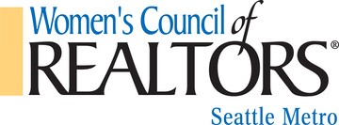

**\*Complimentary Entry:**  Entry in the Strategic Partnership packet is for networking events, & monthly educational events. Free entry is given to the primary contact listed on Strategic Partnerships commitment form. If your strategic partnership allows additional people, those individuals must be listed on the Commitment Form. This benefit is only transferable to individuals at the same company as the Strategic Partner. The request must be emailed to a current WCR Seattle Metro board member.

\***Membership Pricing at Events:** To receive Membership Pricing, tickets should be purchased by the Strategic Partner through the designated event ticket sale platform being used for each event. Membership Pricing is only allowed for the number of people indicated at your Strategic Partnership level.

\***Business Logo Display:** The size of the logo and placement of the logo will be determined by the level of Strategic Partnership. The highest level receives the largest size.

\***Presentations:** Strategic Partner presentations will be arranged three months in advance. If you are a Strategic Partner and interested in utilizing this overview, please notify a WCR Board member via email. Provide a headshot, a summary of what you will be presenting, and the format of your presentation.

\***Information Booth:** The information booths at meetings and events will be managed and stocked by the Strategic Partner. Information booths will not be set up on the Strategic Partners' behalf.

\***Sponsoring Events:** The Opportunity to sponsor events will be given to Strategic Partners based on their sponsorship level and will rotate so that all Strategic Partners receive an opportunity to sponsor should they choose to.

The Women's Council of REALTORS® - Seattle Metro is excited to share all our benefits and continue to create for our Strategic Partners.

**If you have additional questions regarding the Strategic Partnership, contact: Lori Hughes, President P) 425-681-4660 E) lori@corcoranlp.com**

# STRATEGIC PARTNER COMMITMENT FORM

I/We, ___________________________________________ am/are committing to the following

Strategic Partnership level in support of the Women's Council of REALTORS ® Seattle Metro.

Company Name:_______________________________________________________________________________ Contact Person: _______________________________________________________________________________ Corporate/Team Level Individuals being included in your membership:

_________________________________________________________________________________________________

_________________________________________________________________________________________________

_________________________________________________________________________________________________

Mailing Address:_______________________________________________________________________________

City, State, Zip: ________________________________________________________________________________

Contact Phone Number:______________________________________________________________________

Email Address of person responsible for payment:__________________________________________

Payment will be made within 30 days of the commitment level selected and can be post-dated.

Sponsorships are not secure until the commitment form has been completed and payment Received. No Refunds.

Sponsorship Begins January 5th, 2024

Please Submit your logo, headshot, and Bio upon submission of this form.

Payment option selected: Credit Card or Check

*credit card payment will include a payment processing fee

|  |
| --- |
| **Choose Partnership Levels & Pricing 2024**  **Diamond $10,000 Platinum $5,000**  **Gold $2,500**  **Silver $1,500**  **Bronze $750** |

My Signature below indicates my agreement to this sponsorship.

Signature:__________________________________________________________________ Date:______________

**Payment Information**

**Make checks payable to:**

**Women's Council of REALTORS ® - Seattle Metro**

**Mail Checks to: 4055 Lake Washington Blvd NE Suite 100, Kirkland, WA 98033**

**For online payment: A square invoice requesting payment will be emailed to the email address listed above.**

**Please email the completed commitment form to: wcrseattle@gmail.com & cc' shawna.r@vvhldirect.com**